1. What is LINQ All Method in C#?

The LINQ All Method in C# is used to check whether all the elements of a data source satisfy a given condition or not. If all the elements satisfy the given condition, then it returns true else returns false. There is no overloaded version is available for the LINQ All Method. The definition of the LINQ ALL Method is given below. As you can see in the below image, the ALL Extension method takes one predicate as a parameter.



1. Example to Understand LINQ All Method in C# using Value Type

Let us see an example to Understand LINQ All Method in C# using both Method and Query Syntax. The following example returns true as all the elements are greater than 10 in the integer array. There is no operator called all in Query Syntax, so we need to use Mixed Syntax.

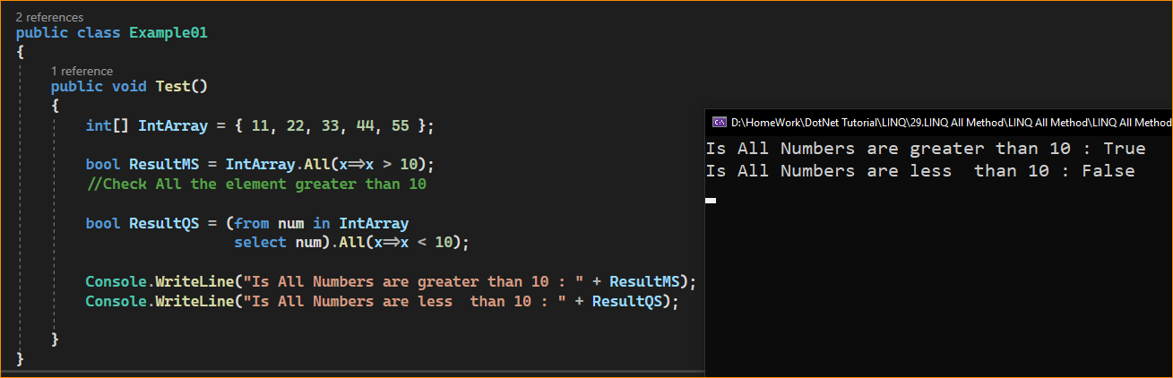

1. Example to Understand LINQ All Method in C# using String Type

Let us see an example to Understand How to use LINQ All Method in C# using String type collection. For a better understanding, please have a look at the following example which shows how to use All Method in C# with String type collection. The following example will return false as all the names are not greater than 5 characters.

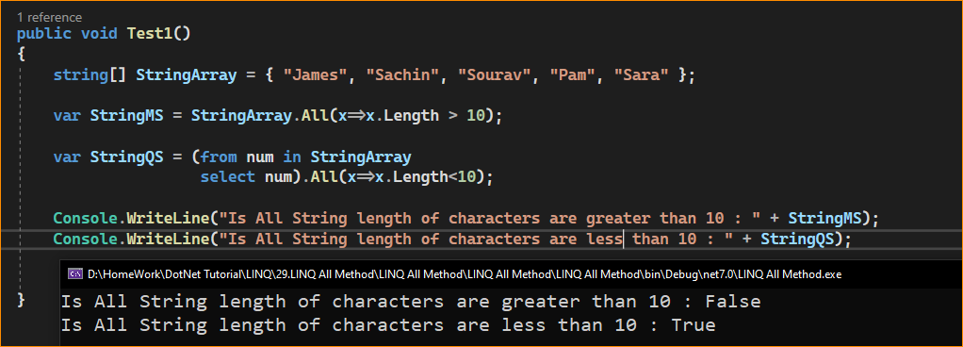

1. Example to Understand LINQ All Method with Complex Type in C#:

Let us see an example to Understand How to use LINQ All Method with Complex Data Type in C# using both Method and Query Syntax. We are going to work with the following Student and Subject classes. So, create a class file with the name Student.cs and then copy and paste the following code. As you can see, the Student class has four properties such as ID, Name, TotalMarks, and Subjects. Here, within the Student class, we have also created one method i.e. GetAllStudnets() which will return the list of all the students. The Subject class has only two properties i.e. SubjectName and Marks.

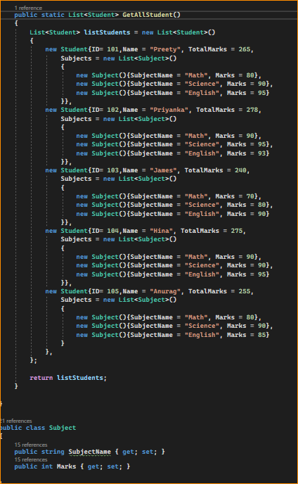

* our requirement is to check whether all the students have total marks greater than 250 or not. As you can see the student James total mark is 240 which is less than 250. So here, the LINQ ALL method will give you the output as false. This is because the All method will return true when all the elements present in the collection satisfy the given condition.

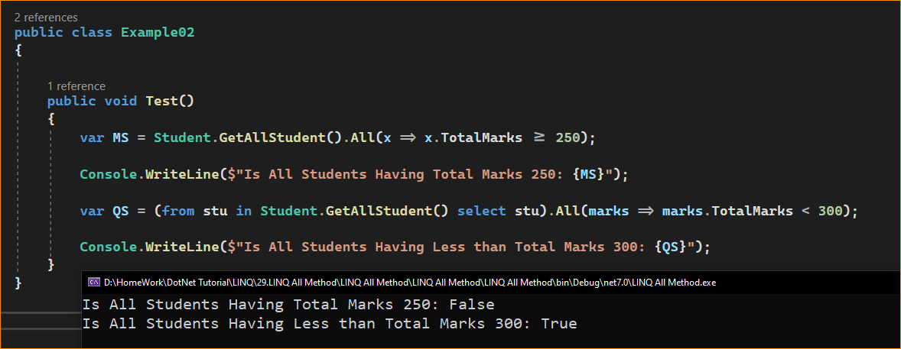

1. Complex Example to Understand LINQ All Method in C#:

Let us see a more Complex Example to Understand the LINQ All Method in C#. If you see our student’s collection, then you will observe that each student object has another collection called Subjects. Now we need to fetch all the student details whose mark on each subject is greater than 80. That means, now we will not apply the LINQ All method to the student’s collection, rather we will apply the LINQ All method to the Subject collection of each student. For a better understanding, please have a look at the following example. As we know, the Where Extension method takes a predicate as a parameter which will return a boolean true and false. Boolean TRUE means that the element will return and False means that the record will not return. Here, within the Where Extension method, on the Subject property, we are applying the LINQ All method. Now, for each student, the LINQ All method will execute and it will check whether all the Subject Marks satisfied the given condition i.e. Marks > 80, and if satisfied, the All Method will return True, and Where extension method will return that Student in output.

